**Project User Manual**

**“SSVEP Classification”**

# BY

**Prashanth H.C**

**1PE14EC099**

**Pavan kumar D**

**1PE14EC094**

**Lakshmiraj C.R**

**1PE14EC412**

**Sawan Singh Mahara**

**1PE14EC128**

**UNDER THE GUIDANCE OF**

**Vidya T.V**

**Assistant Professor, Dept. of ECE, PESIT-BSC**

**Department of Electronics and Communication Engineering**

**PESIT - BANGALORE SOUTH CAMPUS**

**Hosur Road, Bengaluru - 560100**

# ACADEMIC YEAR 2017-2018

**Objective:** To build a core SSVEP classifier using Riemann Manifold clustering of covariance matrices.

**Inputs - Training:** Raw EEG data in the GDF format, with SSVEP events marked.

**Outputs -Training:** Predicted class centres.

**Inputs - Testing:**  Marked, raw EEG data epochs under SSVEP.

**Outputs -Testing:** The final class prediction via the bar chart and confusion matrix.

**System Model:**

Overview

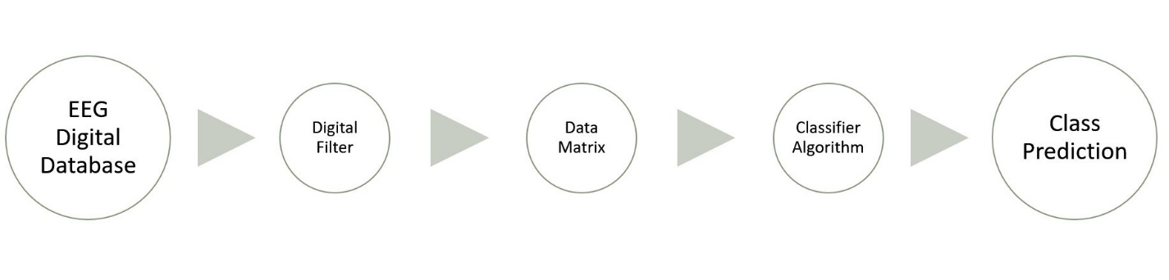

Clustering

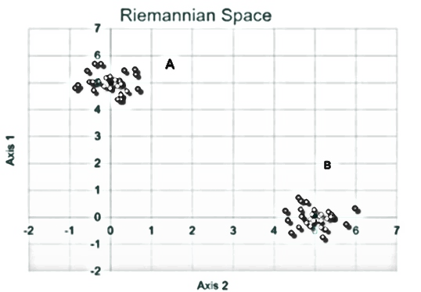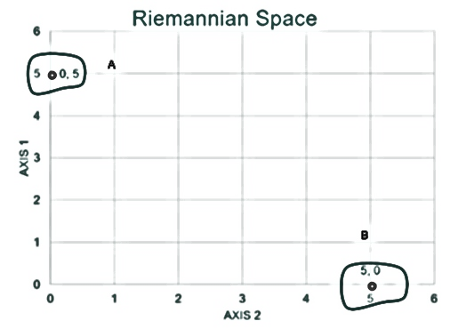

Training Trained Classifier

Training: In this phase, EEG epochs are labelled and stored in the rows of a data matrix. The $C×C$ covariance matrices of each epoch are computed and they each can be considered as a single point in a $\frac{C\left(C+1\right)}{2}$ dimensional Riemannian surface. $C$ is the number of electrodes placed on the subject’s scalp. The similar SSVEP epochs would cluster up near each other as shown in the figure (just for visual representation only) and from the clusters, the centres for each would be found, as shown in the trained classifier.

Testing: To use the classifier, another unlabelled epoch is fed into the system and the algorithm computes the smallest distance of the covariance matrix of this epoch with all class centres. The centre that gives the least distance is then the class which the system predicts as.

**Applications:**

* Disabled individuals, unable to operate wheelchairs with their hands can have an array of flickering lights act as ‘buttons’. This classifier could then be used to detect which light they looked at and then appropriately move the chair.

* A robotic arm could be controlled via an array of lights flickering at different frequencies. The subject can look at any of them and then move the arm in any manner on a 2-D surface to write things on.

**Results:**

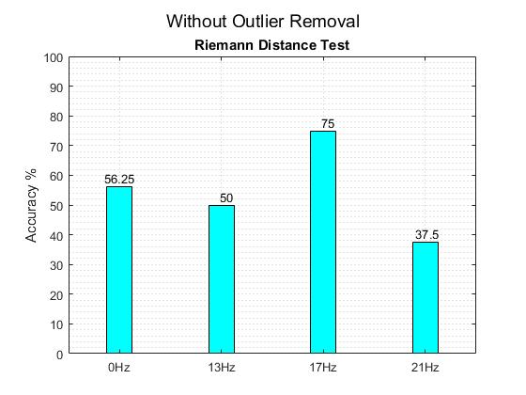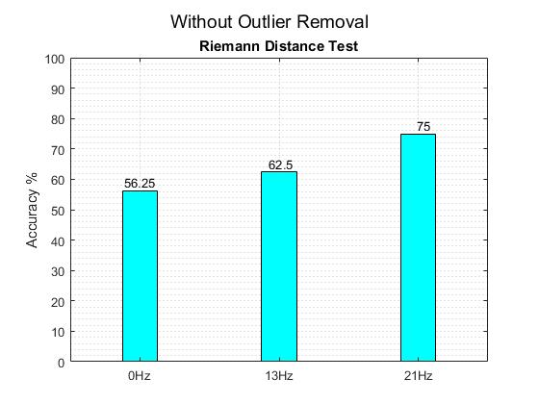

The above show the bar graph accuracies for each class. The number of classes looked at is 4 in the first image and 3 in the next.

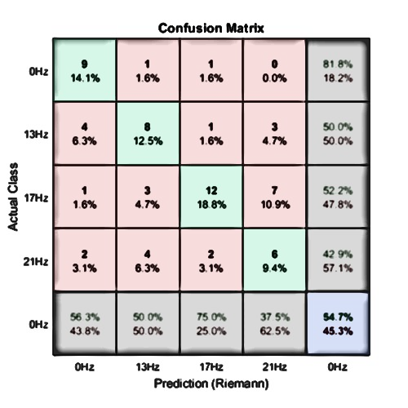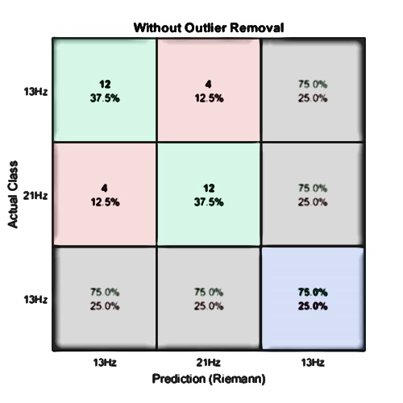

The images above show the confusion matrices for the cases mentioned above, for the bar chart.

**Observations:**

* The classification accuracy increases as the number of class involved reduce.
* The confusion matrix can tell us which class combination gives us the best results as it looks at every possible outcome.

**GUI:**

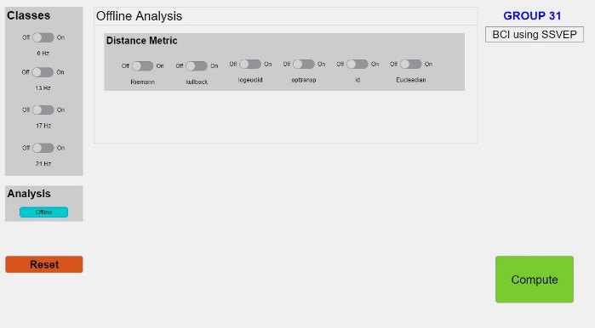

* The image above is a snapshot of the gui built by us. Distance metrics can be selected at will and the number of classes can be chosen as well.
* One can run the GUI to help decide on what distance/class pair can be used on their dataset.